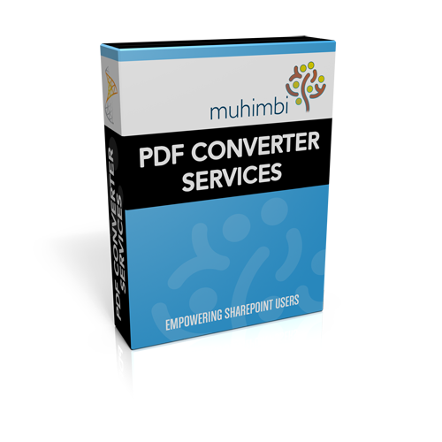

<http://www.muhimbi.com/Products/PDF-Converter-Services.aspx>